# JPEG Example

a) **Block Diagram of Baseline JPEG encoder**

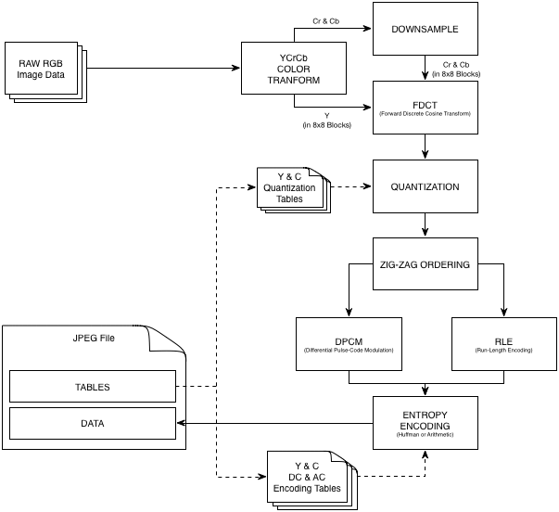

b) **Intermediate Entropy Coding Representation**

The DC and AC values after quantization and zig-zag ordering are converted through the DPCM and RLE into their intermediate entropy encoding representations prior to actually being entropy encoded through Huffman or arithmetic encoding.

For AC values that are not zero there are two symbols used, one that will be entropy encoded into the VLC (Variable Length Code) called Symbol-1 and one that will be entropy encoded into the VLI (Variable Length Integer) called Symbol-2.

Symbol-1 contains a 2-tuple of RUNLENGTH; a count of the preceding ‘0’ values prior to this value in the zigzag order and SIZE; the number of bits required by the 1’s-compliment binary representation of the AC value.

There are two special cases, ‘ZRL’ for runs of exactly 16 zeros, a RUNLENGTH of 15 and SIZE of 0 (with no Symbol-2) is used. When there are no more non-zero values a ‘EOB’ is used with a RUNLENGTH of 0 and SIZE of 0 (with no Symbol-2).

Symbol-2 is the AMPLITUDE of the value given in 1’s-Complement binary.

The DC component is similar but Symbol-1 has no RUNLENGTH value, and the AMPLITUDE in Symbol-2 is the difference from the preceding DC value (DPCM).